**FINAL DELIVERABLE:**

**SELLING ON AMAZON:**

**Structural Business Rules:**

* A Seller can sell many products.
* A product is sold by a single seller.
* Each product belongs to a category.
* A product belongs to a single category.
* A category can have many products.
* Product should have category ID, Name, Price, Quantity.
* An inventory belongs to a single seller.
* A seller can have a single inventory.
* A customer can place many orders.
* An order belongs to a single customer.
* Customer should have username, address, phone number and email address.
* An order can have many products.
* A product belongs to a single order.
* Order should belong to a particular shipping speed.
* A return request belongs to one and only customer.
* A customer can have zero too many return requests.
* Return request should have a Person ID and Product ID.
* A customer can have zero too many customers service request.
* A customer service request belongs to one and only one customer.
* Each order should have a tracking ID.
* A product list belongs to only one order.
* A order list has many order to product pairs.

**CONCEPTUAL ERD:**

**LOGICAL ERD:**

**TABLES CREATION:**

CREATE TABLE prod_category (

category_name VARCHAR(50) NOT NULL,

categ_descript VARCHAR(30),

PRIMARY KEY (category_name)

);

CREATE TABLE products (

product_id DECIMAL(10) NOT NULL,

category_name VARCHAR(50) NOT NULL,

prod_name VARCHAR(30) NOT NULL,

prod_descript VARCHAR(30),

price DECIMAL(10) NOT NULL,

quantity DECIMAL(10) NOT NULL,

PRIMARY KEY (product_id),

FOREIGN KEY (category_name) REFERENCES prod_category(category_name)

);

CREATE TABLE person (

person_id DECIMAL(10) NOT NULL,

username VARCHAR(50) NOT NULL,

phone VARCHAR(30) NOT NULL,

email VARCHAR(30),

address VARCHAR(30),

PRIMARY KEY (person_id)

);

CREATE TABLE seller (

person_id DECIMAL(10) NOT NULL,

brand_name VARCHAR(30),

rating DECIMAL(10),

PRIMARY KEY (person_id),

FOREIGN KEY (person_id) REFERENCES person(person_id)

);

CREATE TABLE buyer (

person_id DECIMAL(10) NOT NULL,

subscription VARCHAR(30),

PRIMARY KEY (person_id),

FOREIGN KEY (person_id) REFERENCES person(person_id)

);

CREATE TABLE inventory (

person_id DECIMAL(10) NOT NULL,

product_id DECIMAL(10) NOT NULL,

product_count DECIMAL(10),

FOREIGN KEY (person_id) REFERENCES person(person_id),

FOREIGN KEY (product_id) REFERENCES products(product_id)

);

CREATE TABLE shipping (

shipping_id DECIMAL(10) NOT NULL,

status VARCHAR(30) NOT NULL,

service_provider VARCHAR(30),

PRIMARY KEY (shipping_id)

);

CREATE TABLE orders (

order_id DECIMAL(10) NOT NULL,

person_id DECIMAL(10) NOT NULL,

shipping_id DECIMAL(10) NOT NULL,

order_status VARCHAR(30),

PRIMARY KEY (order_id),

FOREIGN KEY (shipping_id) REFERENCES shipping(shipping_id),

FOREIGN KEY (person_id) REFERENCES buyer(person_id)

);

CREATE TABLE returns (

return_id DECIMAL(10) NOT NULL,

person_id DECIMAL(10) NOT NULL,

product_id DECIMAL(10) NOT NULL,

reason VARCHAR(30),

status VARCHAR(30),

PRIMARY KEY (return_id),

FOREIGN KEY (person_id) REFERENCES buyer(person_id),

FOREIGN KEY (product_id) REFERENCES products(product_id)

);

CREATE TABLE customer_service (

service_id DECIMAL(10) NOT NULL,

person_id DECIMAL(10) NOT NULL,

serv_type VARCHAR(30),

discript VARCHAR(200) NOT NULL,

status VARCHAR(30),

PRIMARY KEY (service_id),

FOREIGN KEY (person_id) REFERENCES buyer(person_id)

);

CREATE TABLE orders_list (

order_id DECIMAL(10) NOT NULL,

product_id DECIMAL(10) NOT NULL,

quantity DECIMAL(10),

FOREIGN KEY (order_id) REFERENCES orders(order_id),

FOREIGN KEY (product_id) REFERENCES products(product_id)

);

**Stored procedures:**

CREATE OR REPLACE PROCEDURE ADD_person(

person_id_arg IN DECIMAL,

phone_arg IN VARCHAR,

email_arg IN VARCHAR,

address_arg IN VARCHAR,

firstname_arg IN VARCHAR,

lastname_arg IN VARCHAR)

IS

BEGIN

INSERT INTO person

(person_id, phone, email, address, username)

VALUES

(person_id_arg, phone_arg, email_arg, address_arg, firstname_arg || ' ' || lastname_arg);

END;

/

CREATE OR REPLACE PROCEDURE ADD_seller(

person_id IN DECIMAL,

brand_name IN VARCHAR,

rating IN DECIMAL)

IS

BEGIN

INSERT INTO seller

(person_id, brand_name, rating)

VALUES

(person_id, brand_name, rating);

END;

create or replace PROCEDURE ADD_inventory(

person_id_ARG IN DECIMAL,

product_id_arg IN decimal,

product_count_arg IN decimal)

IS

BEGIN

INSERT INTO inventory

(person_id, product_id, product_count)

VALUES

(person_id_ARG, product_id_arg, product_count_arg);

END;

create or replace PROCEDURE ADD_buyer(

person_id_arg DECIMAL,

subscription_arg VARCHAR)

IS

BEGIN

INSERT INTO buyer

(person_id, subscription)

VALUES

(person_id_arg, subscription_arg);

END;

create or replace PROCEDURE ADD_customer_service(

service_id_arg DECIMAL,

person_id_arg DECIMAL,

serv_type_arg VARCHAR,

discript_arg VARCHAR,

status_arg VARCHAR)

IS

BEGIN

INSERT INTO customer_service

(service_id, person_id, serv_type, discript, status)

VALUES

(service_id_arg, person_id_arg, serv_type_arg, discript_arg, status_arg);

END;

create or replace PROCEDURE ADD_SHIPPING(

shipping_id_arg DECIMAL,

status_arg VARCHAR,

service_provider_arg VARCHAR)

IS

BEGIN

INSERT INTO shipping

(shipping_id, status, service_provider)

VALUES

(shipping_id_arg, status_arg, service_provider_arg);

END;

create or replace PROCEDURE ADD_orders_list(

order_id_arg DECIMAL,

product_id_arg DECIMAL,

quantity_arg decimal)

IS

BEGIN

INSERT INTO orders_list

(order_id, product_id, quantity)

VALUES

(order_id_arg, product_id_arg, quantity_arg);

END;

CREATE OR REPLACE PROCEDURE ADD_PRODUCTS(

product_id_ARG IN DECIMAL,

category_name_arg IN VARCHAR,

prod_name_arg IN VARCHAR,

prod_descript_ARG IN VARCHAR,

price_ARG IN DECIMAL,

quantity_ARG IN DECIMAL)

IS

BEGIN

INSERT INTO products

(product_id, category_name, prod_name, prod_descript, price, quantity)

VALUES

(product_id_ARG, category_name_arg, prod_name_arg, prod_descript_ARG, price_ARG, quantity_ARG);

END;

/

**Inserting values:**

BEGIN

ADD_CATEGORY('Electronics', 'related to electronics');

END;

/

BEGIN

ADD_CATEGORY('Computers', 'gadgets related to computers');

END;

/

BEGIN

ADD_CATEGORY('Furniture', 'related to comfort');

END;

/

BEGIN

ADD_PRODUCTS(1, 'Computers', 'acer', 'nitro 5', 600, 10);

END;

/

BEGIN

ADD_PRODUCTS(2, 'Electronics', 'mouse', 'gaming mouse', 20, 15);

END;

/

BEGIN

ADD_PRODUCTS(3, 'Electronics', 'cable', 'ethernet cable', 15, 20);

END;

/

BEGIN

ADD_PRODUCTS(4, 'Electronics', 'cpu', 'with high-end processor', 500, 5);

END;

/

BEGIN

ADD_PRODUCTS(5, 'Computers', 'hp', '2gb ram', 20, 12);

END;

/

BEGIN

ADD_PRODUCTS(6, 'Furniture', 'table', 'glossy finish', 25, 8);

END;

/

BEGIN

ADD_PRODUCTS(7, 'Furniture', 'closet', 'mobile closet', 30, 5);

END;

/

BEGIN

ADD_PRODUCTS(8, 'Electronics', 'self-driving video camera', 'follows a subject', 180, 3);

END;

/

BEGIN

ADD_PRODUCTS(9, 'Computers', 'holographic keyboard', 'tracks virtual key presses', 30, 6);

END;

/

BEGIN

UPDATE prod_category SET categ_descript = 'related to electronics' WHERE category_name = 'Electronics';

UPDATE prod_category SET categ_descript = 'gadgets related to computers' WHERE category_name = 'Computers';

UPDATE prod_category SET categ_descript = 'related to comfort' WHERE category_name = 'Furniture';

END;

/

BEGIN

ADD_person(1, '7745197610', 'AChirra@clarku.edu', '600 main st', 'Adharsh');

END;

/

BEGIN

ADD_person(2, '7749945426', 'PWyner@clarku.edu', '600 main st', 'Peter', 'Wyner');

END;

/

BEGIN

ADD_person(3, '7749945326', 'RJulia@clarku.edu', '600 main st', 'Julia', 'Roberts');

END;

/

BEGIN

ADD_person(4, '7749946326', 'RAlex@clarku.edu', '340 main st', 'Alex', 'Roberts');

END;

/

BEGIN

ADD_person(5, '7749946316', 'RKatie@clarku.edu', '345 main st', 'Katie', 'Roberts');

END;

/

BEGIN

ADD_person(6, '7749946315', 'Rjhon@clarku.edu', '15 main st', 'Jhon', 'Roberts');

END;

/

BEGIN

ADD_person(7, '7749946338', 'jmaverick@clarku.edu', '10 main st', 'Maverick', 'J');

END;

/

BEGIN

ADD_person(8, '7749946356', 'ctom@clarku.edu', '36 main st', 'Tom', 'Cruise');

END;

/

BEGIN

ADD_person(9, '7749946389', 'mtobey@clarku.edu', '79 gem st', 'Tobey', 'Maguire');

END;

/

BEGIN

ADD_person(10, '7749946320', 'jdwayne@clarku.edu', '10 gem st', 'Dwayne', 'Johnson');

END;

/

BEGIN

ADD_seller(1, 'Adharsh', 5);

END;

/

BEGIN

ADD_seller(2, 'PW', 5);

END;

/

BEGIN

ADD_seller(3, 'RJ', 4);

END;

/

BEGIN

ADD_buyer(1, 'prime');

END;

/

BEGIN

ADD_buyer(2, 'prime');

END;

/

BEGIN

ADD_buyer(3, 'prime');

END;

/

BEGIN

ADD_buyer(4, '');

END;

/

BEGIN

ADD_buyer(5, '');

END;

/

BEGIN

ADD_buyer(6, '');

END;

/

BEGIN

ADD_buyer(7, 'prime');

END;

/

BEGIN

ADD_buyer(8, 'prime');

END;

/

BEGIN

ADD_buyer(9, '');

END;

/

BEGIN

ADD_buyer(10, 'prime');

END;

/

BEGIN

ADD_inventory(1, 9, 7);

END;

/

BEGIN

ADD_inventory(2, 5, 6);

END;

/

BEGIN

ADD_inventory(1, 8, 5);

END;

/

BEGIN

ADD_SHIPPING(0, 'not shipped', '');

END;

/

BEGIN

ADD_SHIPPING(1, 'shipping confirmed', 'DHL');

END;

/

BEGIN

ADD_SHIPPING(2, 'shipping confirmed', 'UPS');

END;

/

BEGIN

ADD_SHIPPING(3, 'in process', 'DHL');

END;

/

BEGIN

ADD_orders(1, 1, 0, 'order confirmed');

END;

/

BEGIN

ADD_orders(2, 4, 2, 'shipped');

END;

/

BEGIN

ADD_orders(3, 2, 0, 'order confirmed');

END;

/

BEGIN

ADD_orders(4, 6, 3, 'shipping');

END;

/

BEGIN

ADD_orders(5, 3, 2, 'shipping');

END;

/

BEGIN

ADD_orders(6, 5, 3, 'shipping');

END;

/

BEGIN

ADD_orders(7, 10, 0, 'order confirmed');

END;

/

BEGIN

ADD_orders(8, 7, 0, 'order confirmed');

END;

/

BEGIN

ADD_orders(9, 9, 1, 'shipping');

END;

/

BEGIN

ADD_orders(10, 8, 2, 'shipping');

END;

/

BEGIN

ADD_orders_list(1, 8, 1);

END;

/

BEGIN

ADD_orders_list(2, 2, 1);

END;

/

BEGIN

ADD_orders_list(2, 5, 2);

END;

/

BEGIN

ADD_orders_list(2, 1, 5);

END;

/

BEGIN

ADD_orders_list(3, 9, 3);

END;

/

BEGIN

ADD_orders_list(4, 9, 1);

END;

/

BEGIN

ADD_orders_list(5, 2, 1);

END;

/

BEGIN

ADD_orders_list(5, 9, 2);

END;

/

BEGIN

ADD_orders_list(6, 2, 1);

END;

/

BEGIN

ADD_orders_list(6, 8, 2);

END;

/

BEGIN

ADD_orders_list(7, 3, 1);

END;

/

BEGIN

ADD_orders_list(8, 4, 3);

END;

/

BEGIN

ADD_orders_list(8, 6, 1);

END;

/

BEGIN

ADD_orders_list(9, 5, 7);

END;

/

BEGIN

ADD_orders_list(10, 7, 1);

END;

/

BEGIN

ADD_returns(1, 1, 5, 'poor performance', 'approved');

END;

/

BEGIN

ADD_returns(2, 3, 4, 'defective product', 'pending');

END;

/

BEGIN

ADD_returns(3, 5, 2, 'wrong item received', 'approved');

END;

/

BEGIN

ADD_customer_service(1, 2, 'missing items', 'mouse pad missing in the package delivered', 'waiting for approval');

END;

/

BEGIN

ADD_customer_service(2, 3, 'damaged product', 'product arrived with visible damages', 'in process');

END;

/

BEGIN

ADD_customer_service(3, 5, 'return request', 'customer wants to return the product', 'approved');

END;

/

BEGIN

ADD_customer_service(4, 7, 'refund request', 'customer requests a refund for the order', 'pending');

END;

/

**Updated Values Inserting:**

CREATE OR REPLACE PROCEDURE update_person(

person_id_arg IN DECIMAL,

firstname_arg IN VARCHAR,

lastname_arg IN VARCHAR)

IS

BEGIN

UPDATE person

SET firstname = firstname_arg,

lastname = lastname_arg

WHERE person_id = person_id_arg;

END;

/

BEGIN

update_person(1, 'Adharsh', 'Chirra');

END;

/

BEGIN

update_person(2, 'Peter', 'Wyner');

END;

/

BEGIN

update_person(3, 'Julia', 'Roberts');

END;

/

BEGIN

update_person(4, 'Alex', 'Roberts');

END;

/

BEGIN

update_person(5, 'Katie', 'Roberts');

END;

/

BEGIN

update_person(6, 'Jhon', 'Roberts');

END;

/

BEGIN

update_person(7, 'Maverick', 'J');

END;

/

BEGIN

update_person(8, 'Tom', 'Cruise');

END;

/

BEGIN

update_person(9, 'Tobey', 'Maguire');

END;

/

BEGIN

update_person(10, 'Dwayne', 'Johnson');

END;

/

**Aspect-1:**

***Get those 'Computers' or 'Electronics' goods that cost less than thirty.***

SELECT * FROM PRODUCTS

WHERE PRICE < 30 AND (CATEGORY_NAME='Computers' or CATEGORY_NAME='Electronics');

**Aspect-2:**

***When the number of products in the inventory is <=  to  11, retrieve the names of those products.***

SELECT prod_name FROM products

JOIN inventory ON products.product_id = inventory.product_id AND inventory.product_count <= 11;

**Aspect-3:**

***Using the person table, extract last names & the number of occurrences. Sort by last name and remove entries with a count higher than three.***

SELECT LASTNAME, COUNT(*) FROM PERSON

GROUP BY LASTNAME

HAVING COUNT(*) > 3;

**Aspect-4:**

***Getting the address, first and last names, & person ID for purchases containing three or more goods.***

SELECT orders.person_id, person.firstname, person.lastname, person.address

FROM orders

INNER JOIN person ON orders.person_id = person.person_id

WHERE order_id IN (

SELECT order_id FROM orders_list

WHERE product_id IN (

SELECT product_id FROM orders_list

GROUP BY product_id

HAVING COUNT(*) >= 3

)

);

**Aspect-5:**

***Obtain shipping details about orders placed by customers with Prime Membership.***

SELECT shipping_id, status, service_provider FROM shipping

WHERE shipping_id IN (

SELECT shipping_id FROM orders

WHERE person_id IN (

SELECT person_id FROM buyer

WHERE subscription = 'prime'

)

);

**INDEX CREATION:**

***Query to Optimize:***

Imagine a situation in which we routinely run queries based on the person's table to obtain data using the username. This query is often used, particularly in activities involving users.

***Justification:***

Setting an index on the username column may greatly improve retrieval time and increase the efficiency of queries utilizing this column. Without doing a full table search, indexing enables the database system to quickly find and retrieve the rows connected to a certain username.

CREATE INDEX idx_username ON person(username);

***explanation:***

Faster access to records using the username field will be possible thanks to the newly built index, idx_username. By using the index, the database engine may find the rows that belong to a specific username immediately, saving it from having to scan the whole person table sequentially. Consequently, query efficiency is enhanced, particularly for SELECT queries that contain criteria pertaining to the username field.

**Screenshots:**

SELECT * FROM PERSON;

SELECT * FROM SELLER;

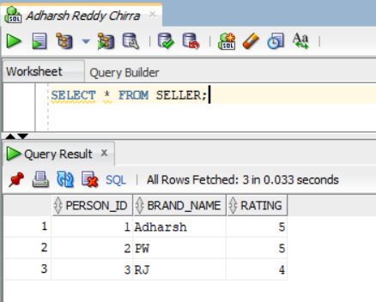

SELECT * FROM INVENTORY;

SELECT * FROM BUYER;

SELECT * FROM CUSTOMER_SERVICE;

SELECT * FROM SHIPPING;

SELECT * FROM ORDERS_LIST;

SELECT * FROM PROD_CATEGORY;

SELECT * FROM PRODUCTS;

SELECT * FROM RETURNS;

***STORED PROCEDURES SCREENSHOTS:***

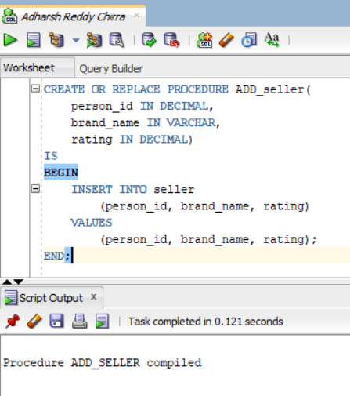

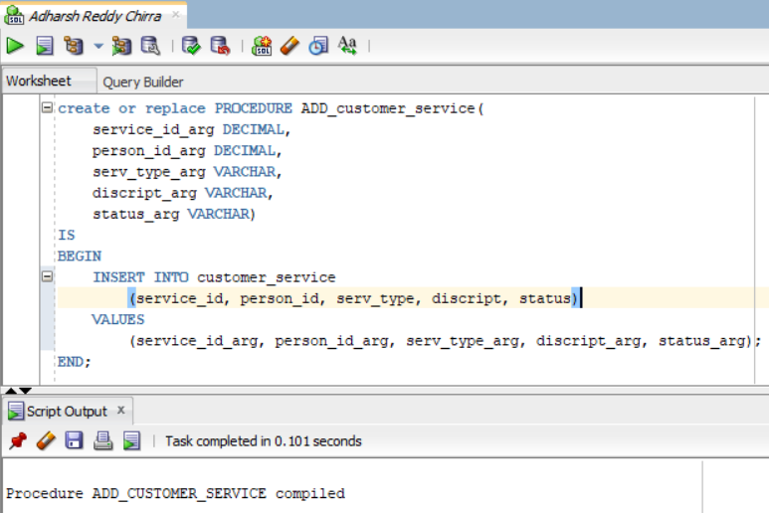

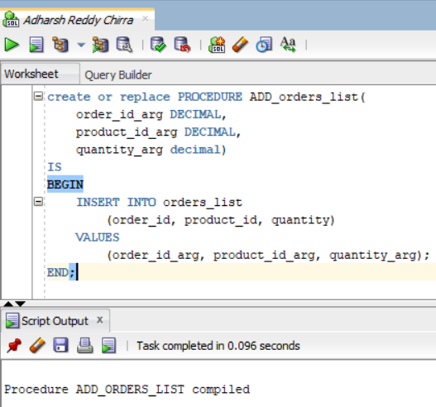

***Updated stored procedures:***

***Updated values inserting:***

